# Harty TYR501 Tire Model – Compilation & Verification Testing

**Compilation:**

This document refers to: ADAMS 2013.1 on Windows 7 64 bit

**Requirements:**

1. Intel Visual Fortran Composer XE for Windows – 2013 edition (Note that ADAMS is very fussy about which exact version of the compiler is in use)

**Subscription details:**  
Original Product Serial Number: CH95-H9NGGMGH  
Original Product SKU: No SKU Associated  
Product Name: Intel® Visual Fortran Composer XE for Windows*  
License Type: Named-user

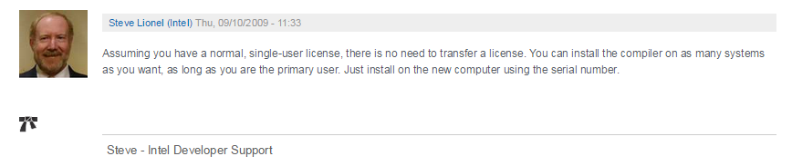

(Taken from <https://software.intel.com/en-us/forums/topic/294432>)

Download the installer from \\polarisind.com\apps\caedocs\MBD\Motorcycle\PI-Moto Templates & run it

1. Source code files

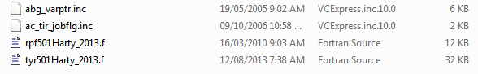

1. Build & Installation files



**Process:**

1. Ensure requirements are met
2. Open Intel command window:

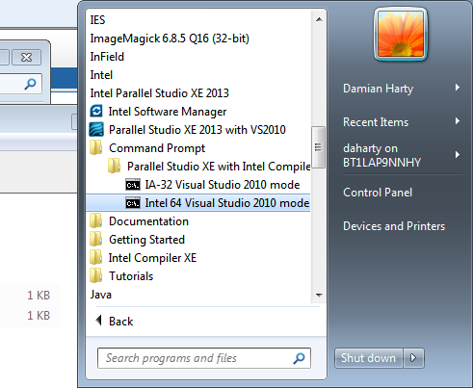  
(Any old command window won’t do. Check the header of the window for this title:

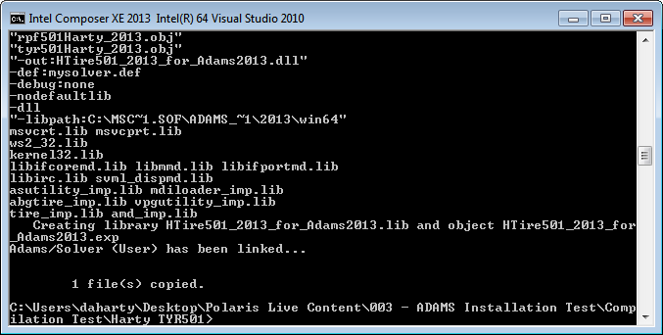

1. Navigate to where source code & build files are kept using cd <folder_name>
2. Type 01-build_me_2013.1.bat
3. Check for success:  
   

Testing: “TG2” Datum tire (motorcycle style data)

## Free Running

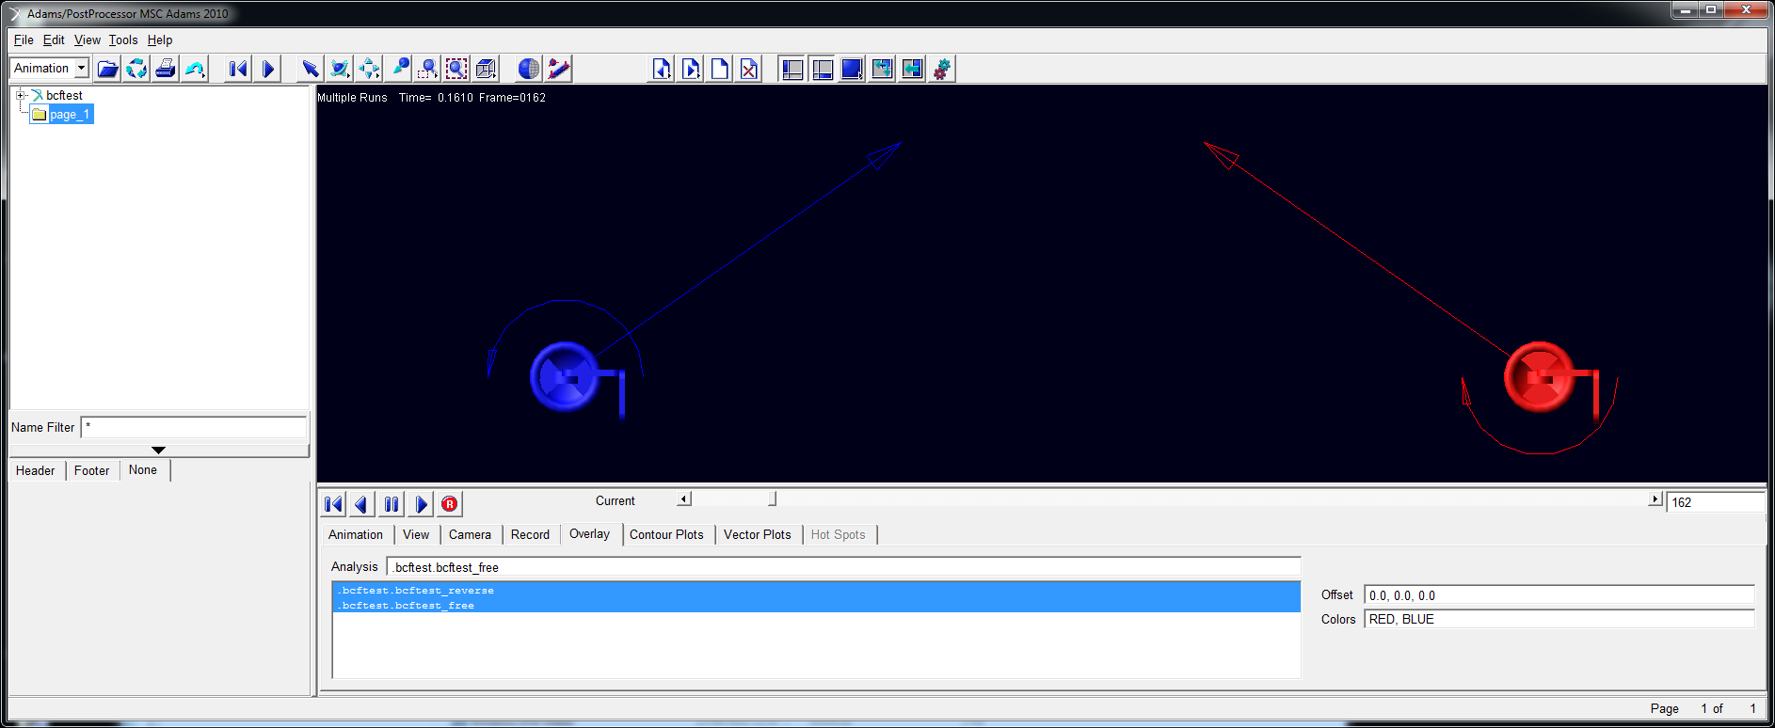

Forward & Reverse running check (sample TYR501 doesn’t achieve this)

* Check direction of force during landing transient with stationary wheel (should pull back on rig)
* Check direction of wheel spin moment at same time (should spin up wheel)
* Check steady state results (wheels spinning in correct direction, rolling resistance pulling back on rig)

## Side Force with Slip Angle

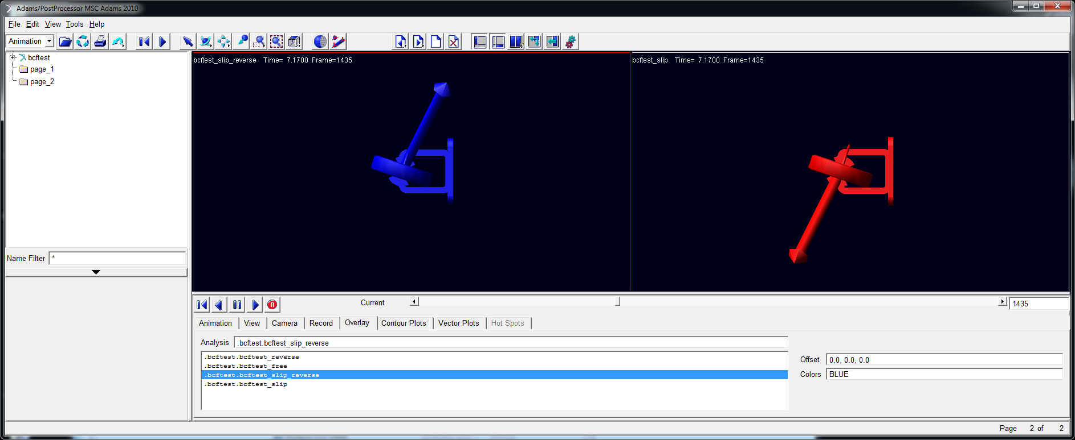

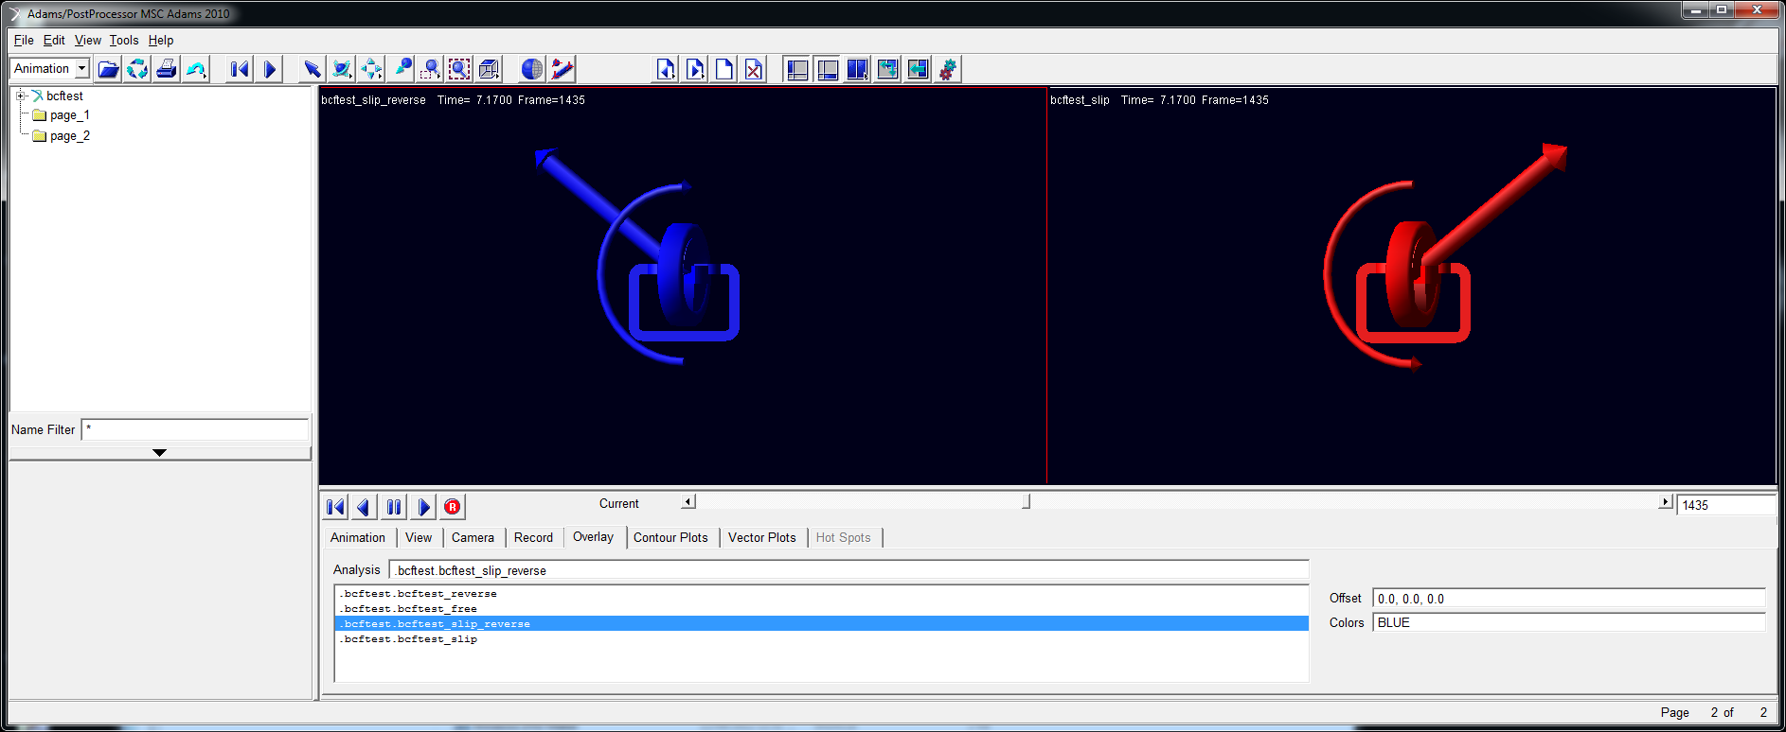

Side force in pure slip (forward & reverse). Overturning moment correct.

## Side Force with Camber

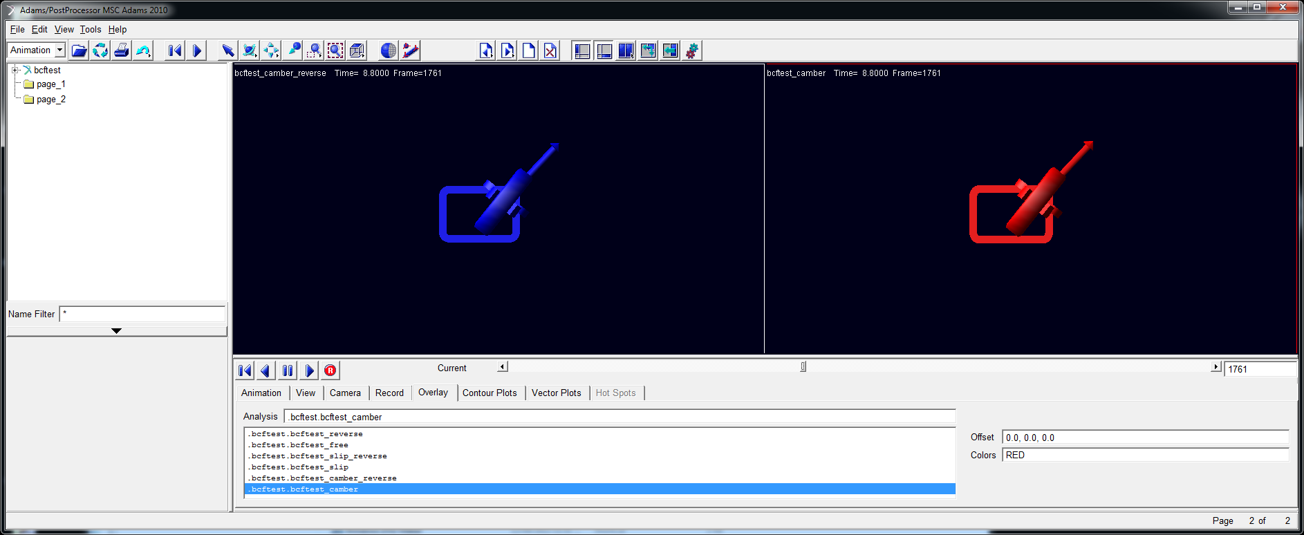

Side forces in pure camber (forward & reverse).

## Longitudinal Force with Tractive Slip

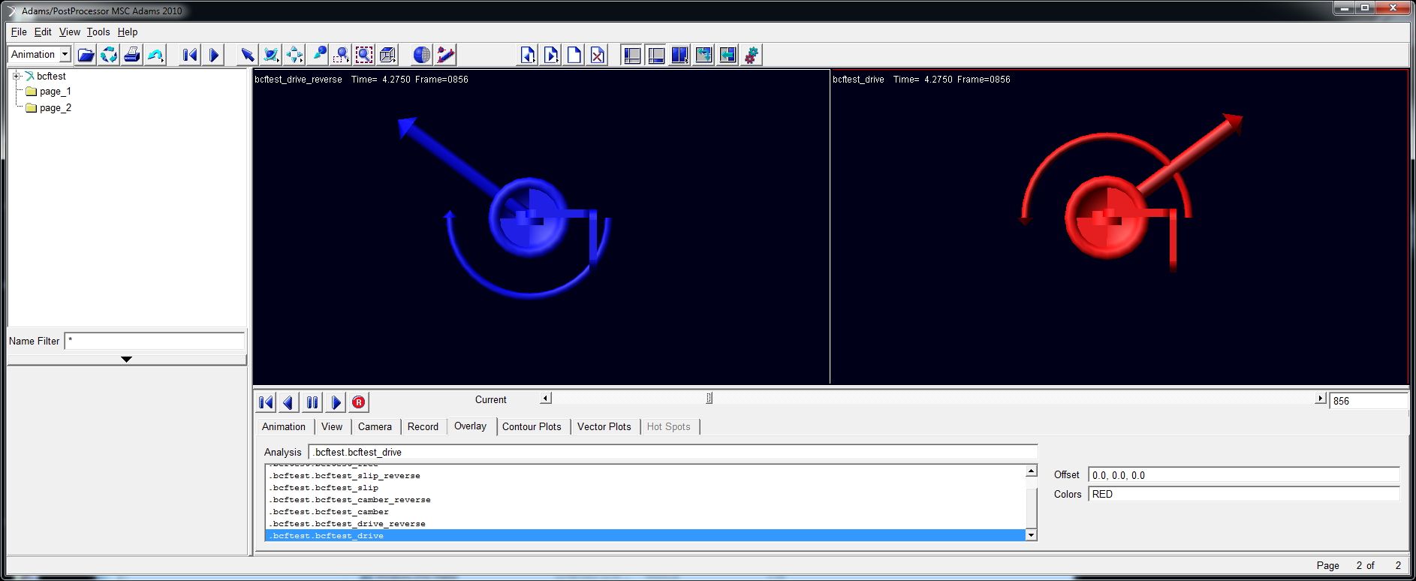

Pure driving (100% overspeed)

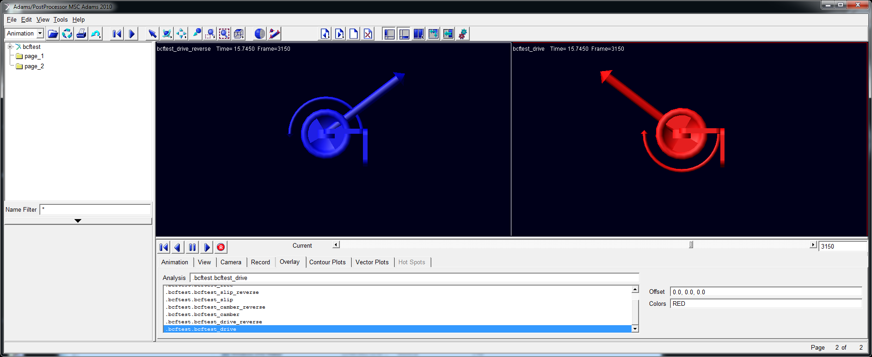

r

Pure braking (wheel stationary)

## Tractive Slip and Slip Angle

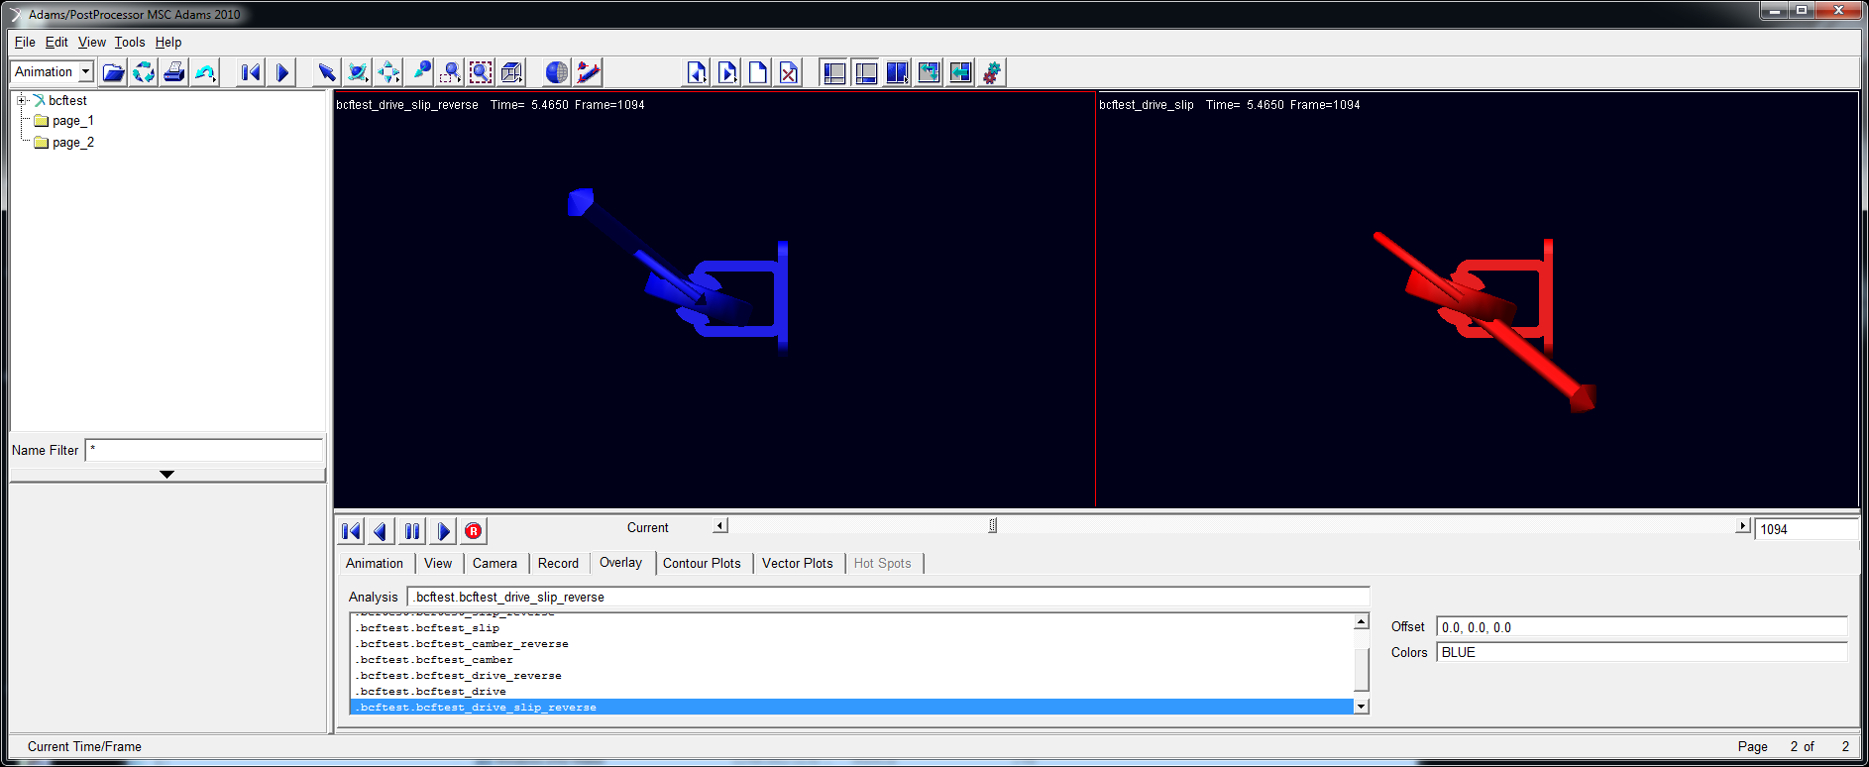

r

Comprehensive slip – drive and slip angle (100% overspeed)

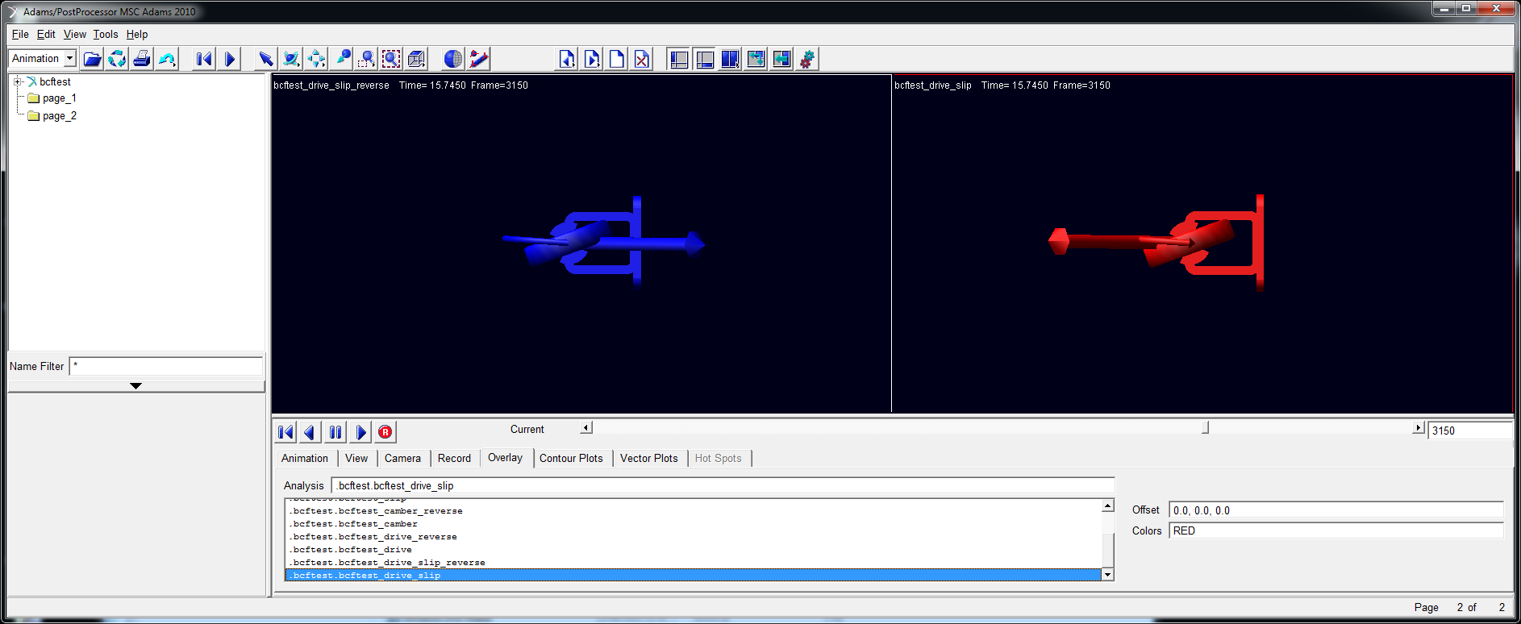

r

Comprehensive slip – braking and slip angle (wheel stationary)

## Tractive Slip and Camber Angle

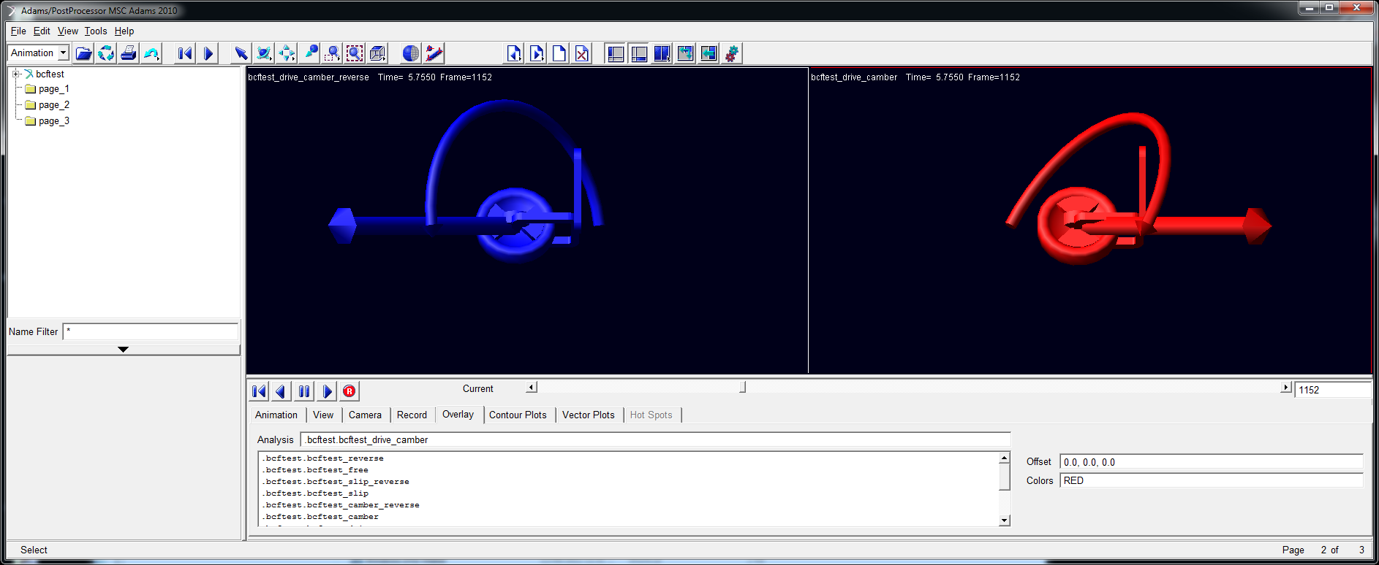

r

Comprehensive slip – drive and camber angle (100% overspeed)

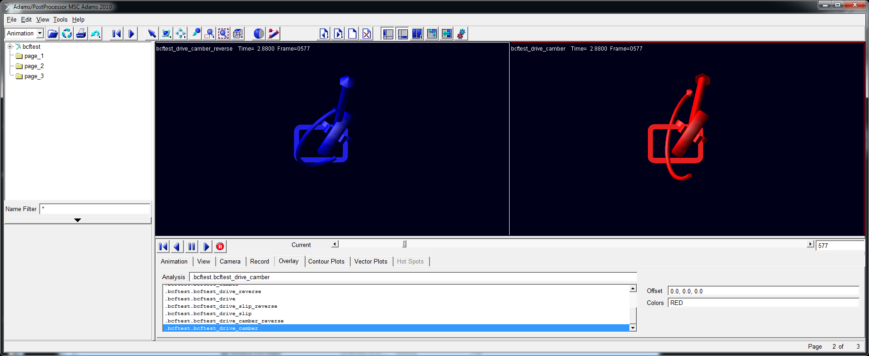

Comprehensive slip – drive and camber angle (partial overspeed, check sign of lateral force)

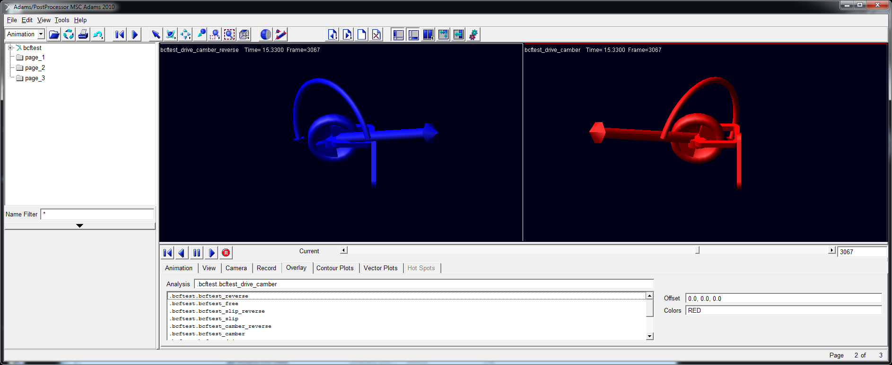

r

Comprehensive slip – braking and camber angle (wheel stationary)

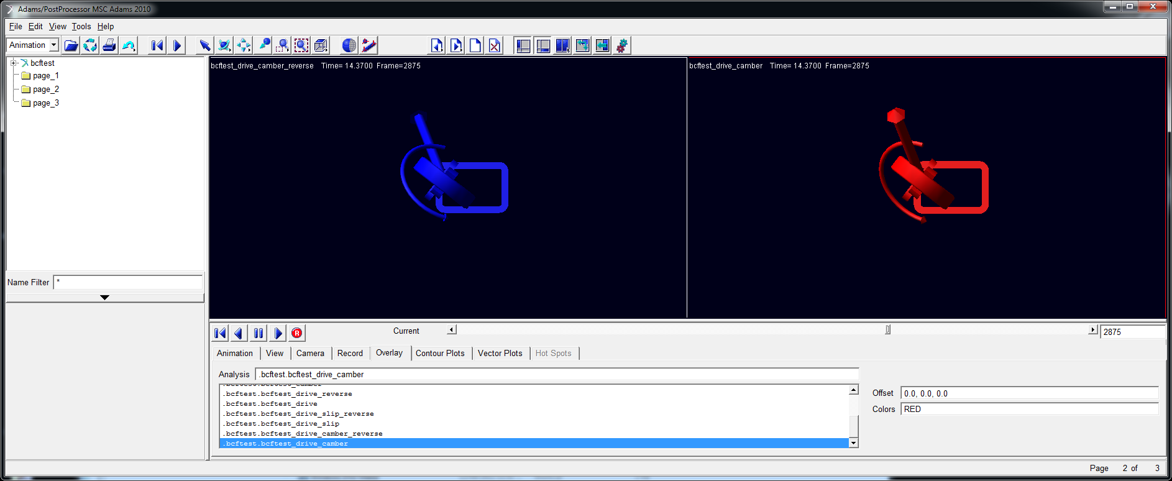

Comprehensive slip – braking and camber angle (partial underspeed , check sign of lateral force)

## Camber and Slip Angle

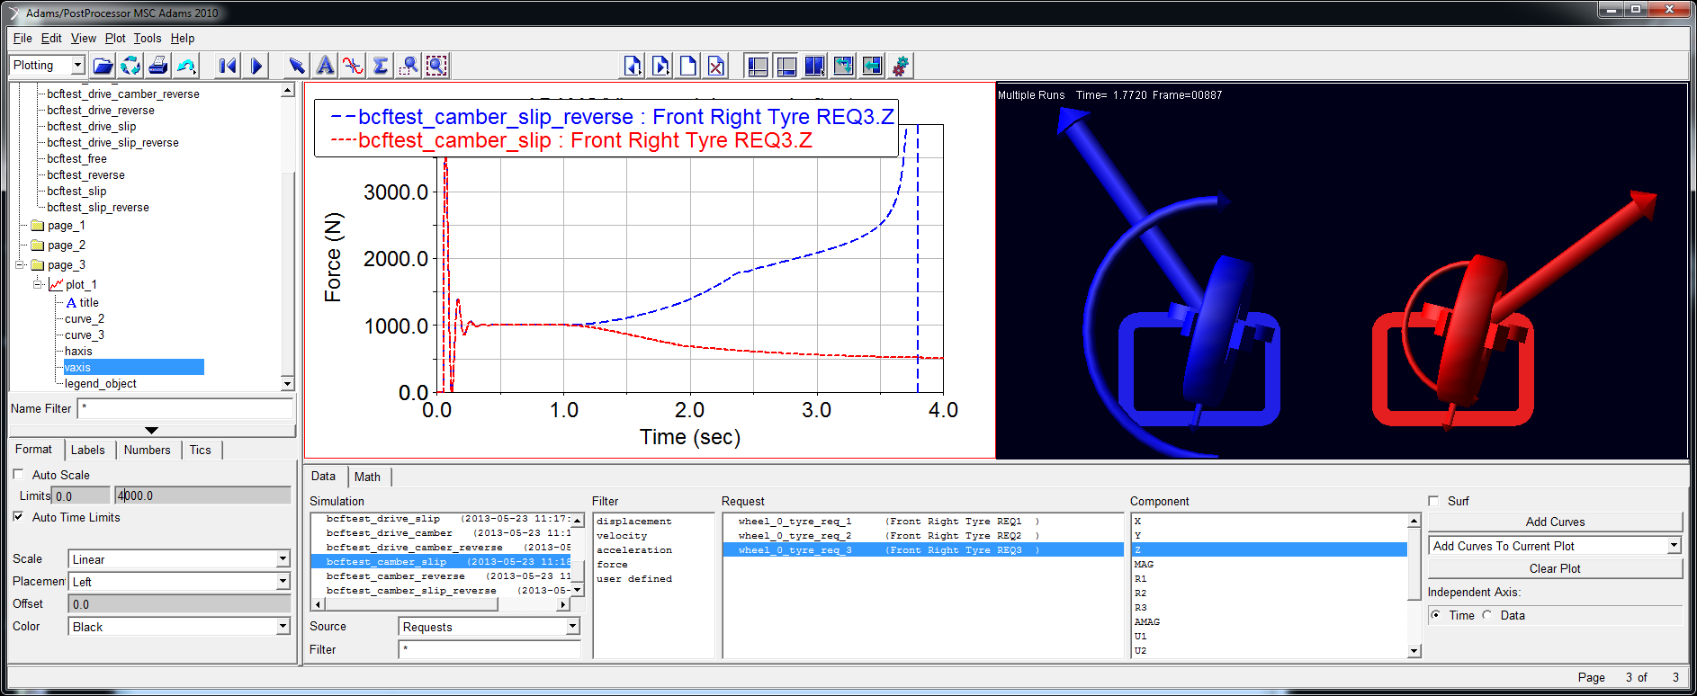

Combined camber and slip – note that reverse direction has “positive anti geometry” and vertical loads go unstable, preventing full solution – a textbook illustration if ever there was one!

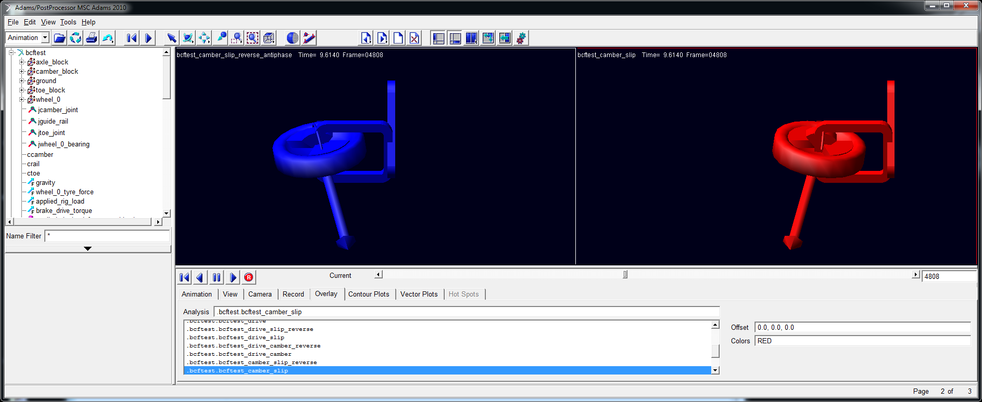

r

Combined camber and slip with mirrored (“antiphase”) solutions showing tire model functions in both running directions.

## Tractive Slip, Camber and Slip Angle

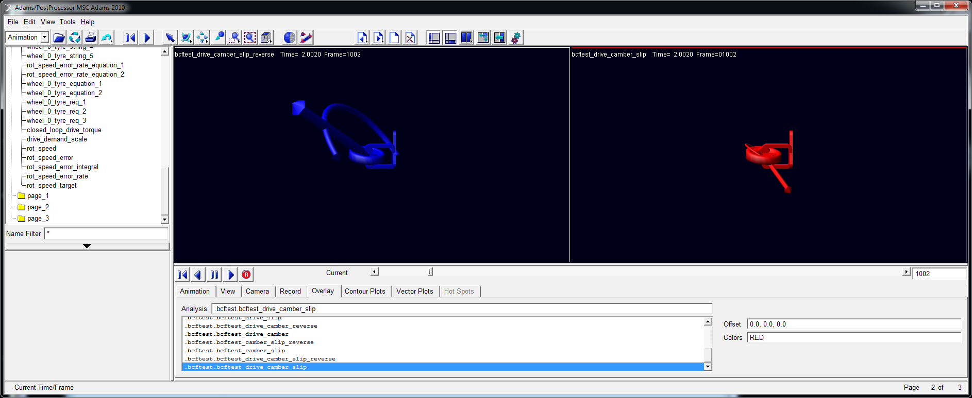

r

Combined drive, camber & slip – partial overspeed; note forward/reverse asymmetry caused by “anti-geometry” effect.

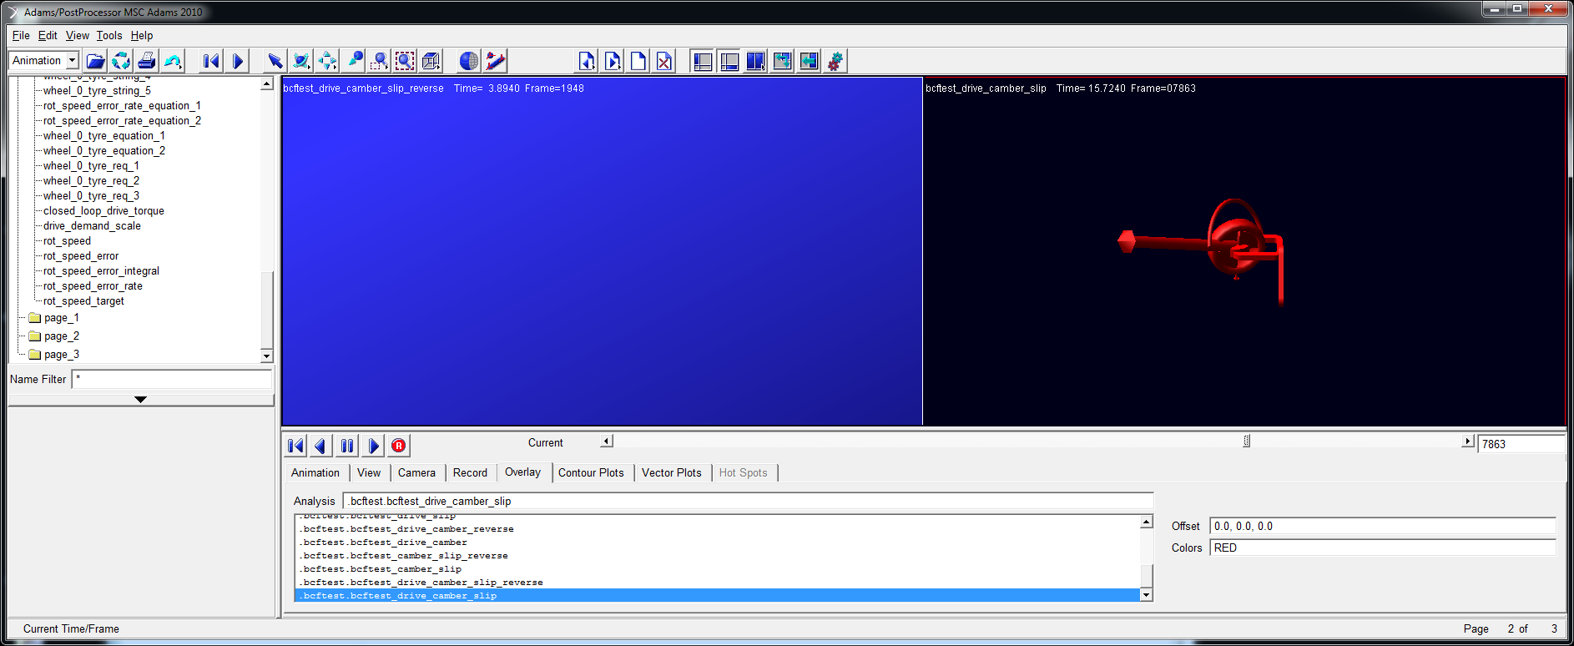

Combined drive, camber & slip – wheel stationary; note failure to converge of reverse solution due to anti-geometry effect

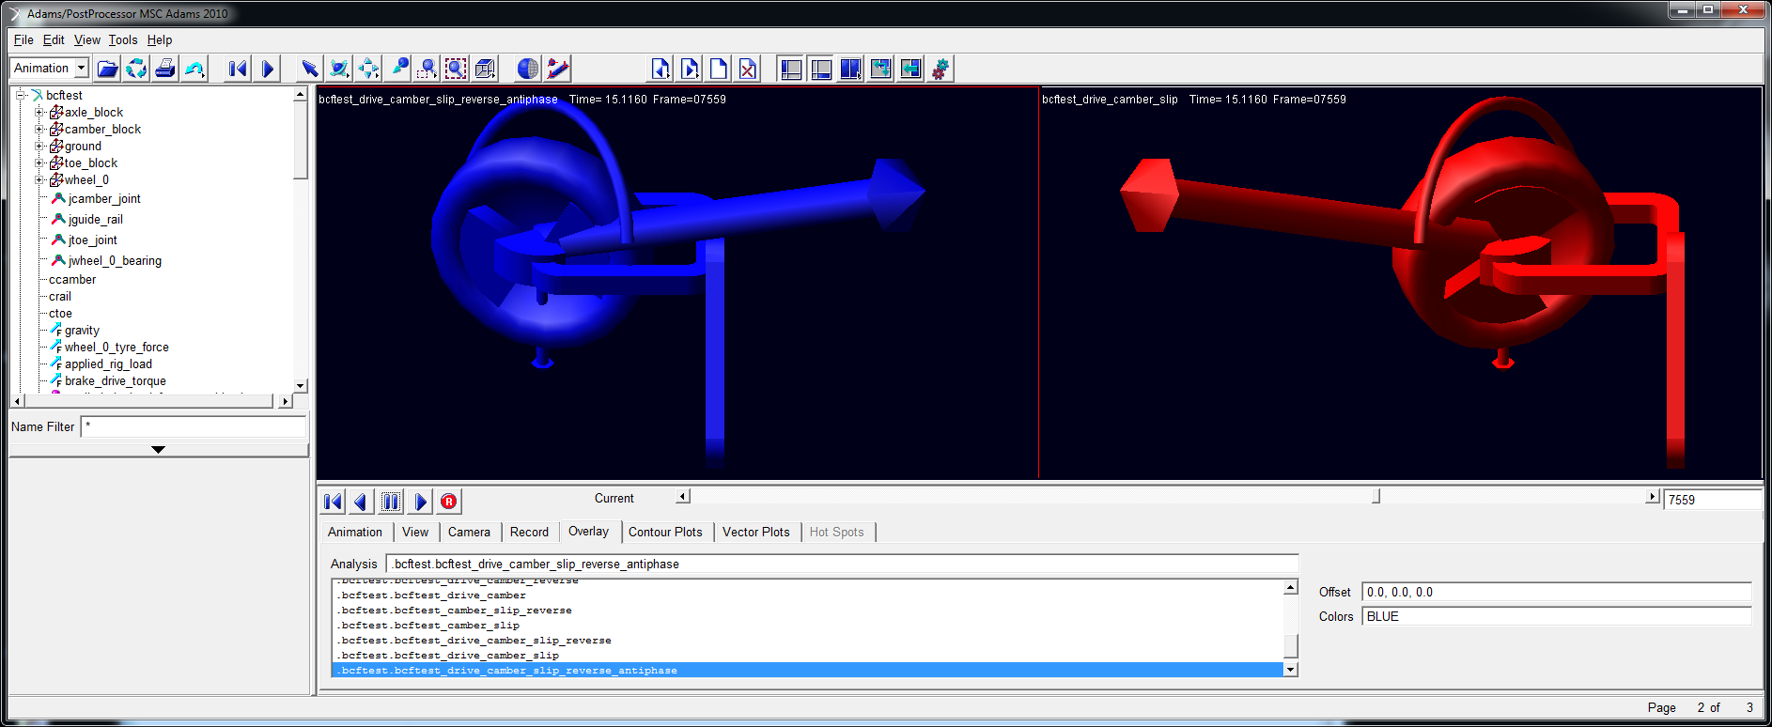

Combined drive, camber & slip – wheel almost stationary, showing mirrored (“antiphase”) solutions verifying comprehensive slip performance in both running directions.

**APPENDIX – What is this Tire Model?**  
Text below from: “The Multibody Systems Approach to Vehicle Dynamics”, 2nd Edition. See also “Intermediate tyre model for vehicle handling simulation”, Journal of Multibody Dynamics, 2006 (JMBD51.pdf).

**The Harty Tyre Model**

A desire to have a simple, computationally light tyre model that captured directionally the behaviour of real tyres led to the development of a TIRSUB routine for use with MSC ADAMS in early 1996. The model has progressed over time and has been migrated into a more modern TYR501 subroutine, still in FORTRAN. The source code is reproduced in Appendix B. The starting point for the model was the sample routine for coding the Fiala model supplied with the software and so useful aspects of the Fiala model were re-used.

As with the Fiala model, tyre states are presumed passed into the model:

* longitudinal slip state, Sx (slip ratio) as a decimal fraction with -1 representing a locked wheel, 0 representing a free-rolling wheel and greater than zero representing driving
* lateral slip angle in radians, 
* presentation (inclination) angle in radians, 
* vertical deflection of the footprint imposed by the road in mm DZ
* vertical footprint velocity, VZ
* a flag denoting spin direction

Vertical load, *Fz*, is calculated using a linear stiffness and damping ratio and is not described explicitly as it is somewhat trivial. The existing Fiala friction coefficient treatment is retained. It is observed that, over the load range of interest in road vehicle handling, both the slip angle at which peak side force is produced and the slip ratio at which peak longitudinal force is produced do not actually vary much. Thus they are declared as constant. While clearly an approximation, it remains useful.

It is noted that measured tyre data for both lateral and longitudinal force in pure slip displays a characteristic convex form, which can be generated using a single additional parameter, a curvature factor, *A*:

 (5.79)

 (5.80)

For the lateral slip angle case, some ability to scale lateral and longitudinal forces independently is desired and so an additional scaling factor, B is introduced. Load sensitivity is also present in the lateral formulation (but not the longitudinal formulation; this is arguably a simplification too far) by introducing a reference load RZ and a scaling-factor-to-vertical force sensitivity term, labelled dB_dFz in the software code:

 (5.81)

 (5.82)

With inclination angle/presentation angle, the typical taut string idea that force is generated in the plane of the tyre is used with a simple camber coefficient, *C*. However, a naïve formulation using only the tangent of the angle tends to produce unreasonably high forces as the tyre leans over more, and also does not respect the friction limit. Therefore a formulation is made which sets a fractional threshold, *T*, beyond which a clipping function is used:

 (5.83)

 (5.84)

 (5.85)

 (5.86)

This apparently complex form is entirely empirical and produces a smooth blend to the friction limit even at extended lean angles, as may be seen in Figure 5.77, where the upper figure was produced with a threshold of 0.7 and the lower figure with a threshold of 0.9.

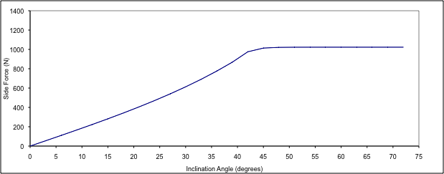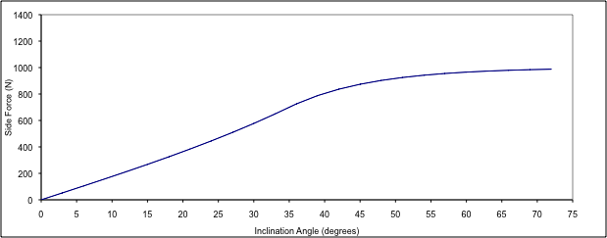Figure 5.77 Harty tyre model showing camber clipping with different clip thresholds, T=0.6 (upper), T=0.9 (lower)

Lateral forces due to slip and inclination angles are added algebraically to generate a total side force.

This side force and the longitudinal forces together are combined into a comprehensive slip force, which is compared to the available friction in a straightforward Pythagorean way. The multiplier *B*, described earlier, is re-used to make the “circle of friction” into something elliptical; it can be seen that the ellipse can go either way depending on whether B is greater than or less than unity.

 (5.87)

 (5.88)

 (5.89)

Although appearing algebraically complex, this is a very simple formulation which simply truncates the combined force vector as it crosses the friction ellipse. The concept is illustrated in normalised form in Figure 5.77.

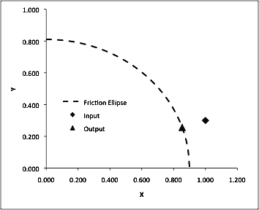

Figure 5.78 A normalised representation of the comprehensive slip formulation within the Harty tyre model at low levels of slip

This formulation behaves well at low levels of slip but becomes confused when the slip levels become high in the tyre, such as the case of a locked wheel or with gross wheelspin. Under these circumstances a different approach is taken, which is to calculate the velocity vector of the contact patch with respect to the ground and to apply a simple Coulomb-style frictional force in the opposite direction. Note that there are none of the numerical difficulties associated with the Coulomb formulation around zero speed because this model is only applied when the contact-patch-to-ground speed is substantial:

 (5.90)

 (5.91)

Note that when using this formulation, slip angle  is expressed in radians and longitudinal slip, Sx is a fraction and not percentage. These two slip quantities are simply blended between a longitudinal slip ratio of 50% and 100% in either direction, which is to say only in the gross wheelspin or near lock condition. The resulting force vectors appear directionally correct. However, it must be said that this final elaboration in the comprehensive slip calculation is really only necessary for simulations where this deep slip condition is of interest, such as perhaps in a video game or perhaps in some A:B comparison animation of, say, behaviour with locked wheels vs behaviour without; in general this deep slip model is unnecessary.

Once the aggregate contact forces have been rescaled for comprehensive slip, computations for the various moments can be made using them.

Overturning moment or capsize moment is calculated with a very simple function involving the width of the tyre and an overturning moment coefficient, *CMX* ; a value of unity for *CMX* produces no overturning moment and mimics a blade wheel. Values of greater than unity saturate the aligning moment when an imagined contact point has moved laterally by half the width of the tyre. For car tyres, this happens at around 5° of inclination angle but for motorcycle tyres it is often at or beyond 45° of inclination that the tyre contact centre of pressure is closest to the edge of the tyre. Simple trigonometry is used to move the notional contact point laterally and the vertical load is multiplied by this lever arm:

 (5.92)

 (5.93)

Aligning moment is also comprised of two components, one from slip and one from camber in a similar manner to side force.

A notional contact patch length is calculated geometrically from the deflection passed in to the routine and a notional pneumatic trail used with the slip-angle-induced side force to generate an aligning moment. Note that the side force is that produced by the comprehensive slip truncation Fy1 or Fy2 depending on the operating regime. It is observed studying measured tyre datasets that the pneumatic trail decreases in a broadly linear way with increasing slip angle, and so the calculation of pneumatic trail is kept deliberately simple apart from the addition of an empirical, MF-style scaling factor:

 (5.94)

 (5.95)

 (5.96)

It will be noted that progressing beyond the critical slip angle produces increasingly reversed values of aligning torque, which is unlikely to be true in practice. In most vehicle dynamics simulations (and real driving conditions), slip angles of this magnitude constitute an error condition; in any case reliable tyre measurements in this region are difficult because of the high thermal loads on the tyre – again this formulation is a clear choice of “simple and wrong” over “complicated and wrong”.

For camber-induced moments, it is noted that they are in the opposite sense to steer torque moments. A “pneumatic lead” - conceptually opposite of pneumatic trail – is introduced to calculate camber-induced moments, again scaled with an MF-style factor:

 (5.97)

 (5.98)

Again it is noted that the camber forces are scaled according to the comprehensive slip truncation. Naive but functional calibrations of the model may be obtained by setting all scaling values to zero save for TPC and LPC, which can be set to unity and 25mm, respectively.

Final aligning and capsize moment contributions come from applied longitudinal forces with the lateral shift of the contact patch centre of pressure under non-zero inclination angles. This is particularly important for motorcycles as it generates an uncommanded steer moment which will steer into the turn and thus reduce roll rate. Its importance is relatively minor for passenger cars although it can improve prediction of overall steering return torque.

 (5.99)

For 

 (5.100)

 (5.101)

For 

 (5.102)

 (5.103)

The rolling resistance moment My is identical to the Fiala formulation and is given by:

My = -Cr Fz (forward motion) (5.104)

My = Cr Fz (backward motion) (5.105)